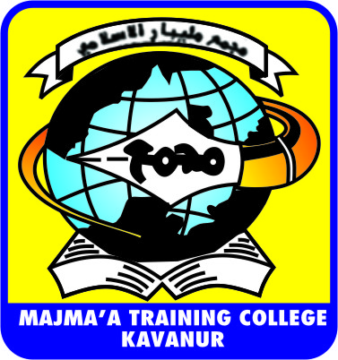
MAJMA’A TRAINING COLLEGE, KAVANUR
STUDENTS LIST ENGLISH 2014-15
1 ABDUL RAHMAN KODAKKADAN
2 ABDUL RAHOOF .M
3 ABDUL SALEEM. M.K
4 ASWATHI. V P
5 DEEPTHI .K
6 FAHIZ . P
7 FASIL . M
8 HARISHMA. K
9 HIMA. K.
10 JAFNES K.
11 JASEELA. K.
12 JASNA P
13 JAYARAJ. K.P
14 JITHIN. E.M
15 MIQDAD. T
16 MUFEEDA. P.
17 MUHAMMED SAMEER. N.K
18 NAJLA JASMIN. E.K.
MAJMA’A TRAINING COLLEGE, KAVANUR
STUDENTS LIST ENGLISH 2014-15

19 NAJMUNNISA. C.P
20 NASEEBA.P.
21 NINISHA. T.P.
22 NISHIDA. K
23 NIYAS. K.
24 SANDYA. K.M.
25 SHABANAMOL. M.P
26 SHAHUL HAMEED . M.
27 SHAMNA.M
28 SHARUN P.B
29 SHYMA MOL .V.P
30 SIRAJUDHEEN . P
31 SRUTHI M
32 SUHAIL MP
33 SUMAYYA. K
34 YOUNUS. C.H.

MAJMA’A TRAINING COLLEGE, KAVANUR
STUDENTS LIST MATHEMATICS 2014-15

1 AMJATHA JASMIN. T
2 ANEES. C
3 ANJANA. O.R
4 LABEED PARAMBADAN
5 MUHSINA. E. K
6 MUMTHAZ BEEGUM. A.K
7 NAJMUNNEESA.P
8 RAIHANATH. V
9 RAMSEENA. V
10 RISHLA. V.P
11 SAFNA .K.E
12 SIBINA SUNDAR.T

MAJMA’A TRAINING COLLEGE, KAVANUR
STUDENTS LIST PHYSICAL SCEINCE 2014-15
1 ARUN B. NAIR
2 ASWATHI .C
3 BUSHRA. P
4 FATHIMA NAHILA. C.K
5 FIDA M.P
6 HAFEEFA. K. C
7 JAMSEERA. P.T.K
8 JUNAID. M.P
9 MOHAMMED IRSHAD. M.A
10 MUHAMMED SHAREEF. T
11 MUNAVVARA. A.P.
12 NASIYA.P
13 NEETHU.V.T
14 PRANAV. K.T
15 RAHMATHUNNISA. N.T
16 RAIHANATH. T
17 SABNA. E.
18 ZEENATH K K
MAJMA’A TRAINING COLLEGE, KAVANUR
STUDENTS LIST SOCICAL SCEINCE 2014-15

1 ABDURAFIH. V. K
2 AFIYA .V
3 AHAMMED FASIL
4 AMINA .E
5 AMRUTHA A
6 ANJU KRISHNA. M.T
7 ASHITHA .T.
8 ATHIRA.P
9 DHANYA.A.P
10 DINUMON
11 DIVYA MOL. V
12 DIVYA. P
13 HARSHA. M
14 LASITHA .P
15 LINCY.P
16 MUHAMMED MUSTHAFA. M.
17 MUHAMMED SHAFI.T.K
MAJMA’A TRAINING COLLEGE, KAVANUR
STUDENTS LIST SOCICAL SCEINCE 2014-15

18 MUHAMMED.K
19 MUHSINA. P. P
20 MUNEERA. M
21 NEENU. T
22 PRABHEESH MOOTHEDATH
23 SABNA PUTHUPPARAMBIL
24 SAINUL ABUDEEN .P
25 SAJNA. O.P.N.
26 SHINITHA T.
27 SUBEESHNA. K
28 UMMU SALMA T.P

